Creating IAM User
Objective : To understand how to create and manage IAM users in Amazon Web Services.
- To learn how to provide secure access to users by setting passwords and access types.
- To understand how to assign appropriate permissions to users for accessing AWS services..
Step1: Sign in into AWS console
- Go to: https://aws.amazon.com
- In the search bar, type IAM
Click on IAM (Identity and Access Management)
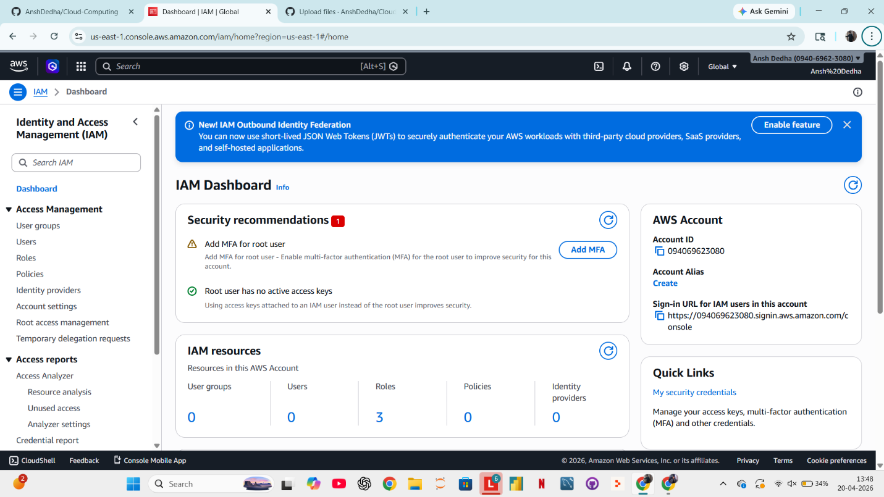
Step-2 : Create a User Group
- In the left panel, click User Groups
- Click Create group
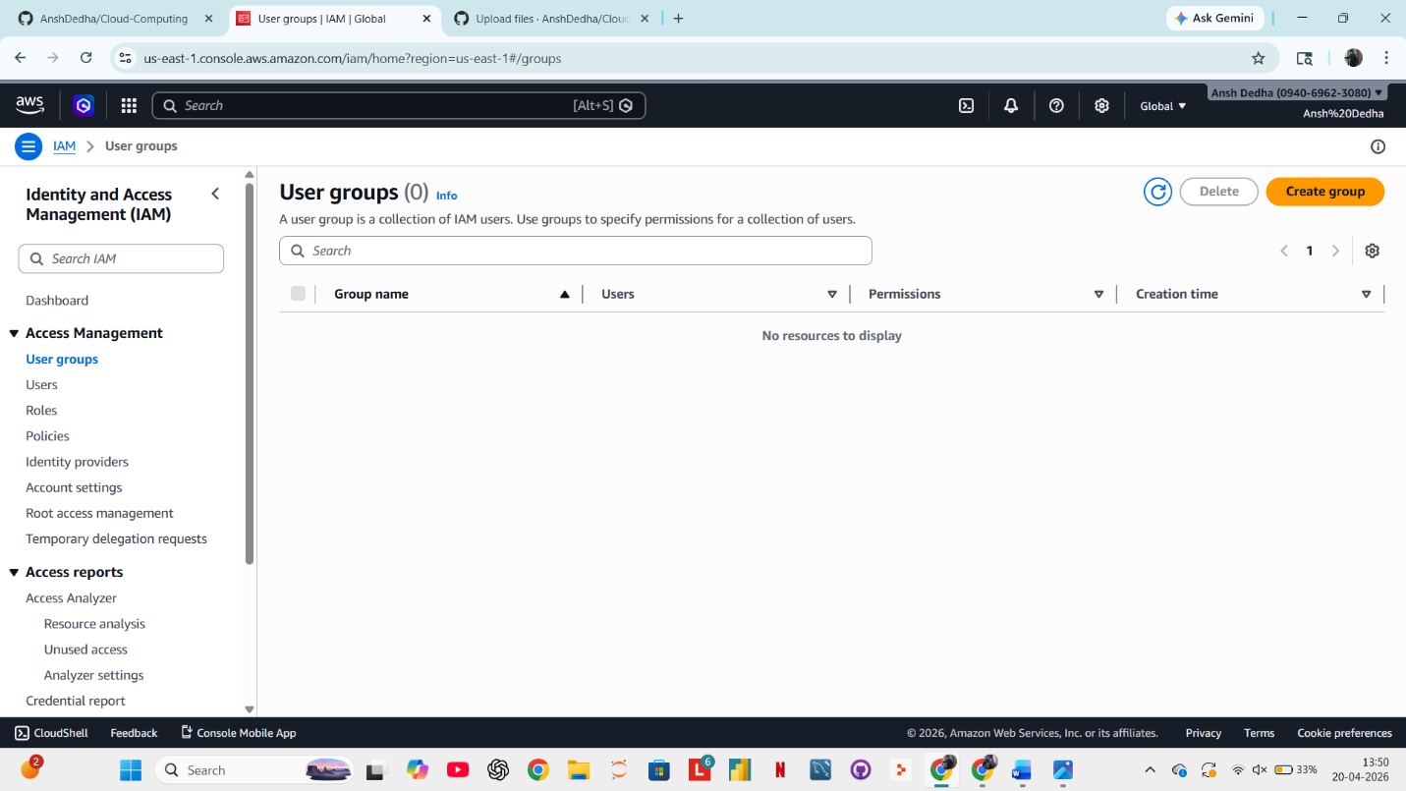
Step-3 Specifying User details
- Give an appropriate name to the user
- Provide a password for the login credential(it can be autogenerated or custom)
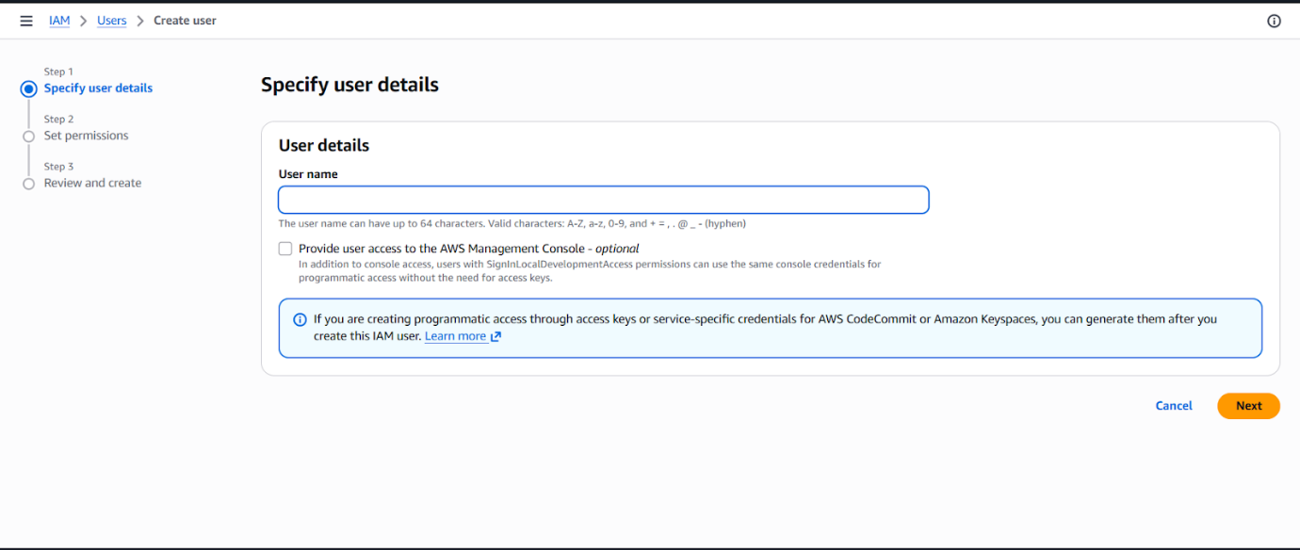
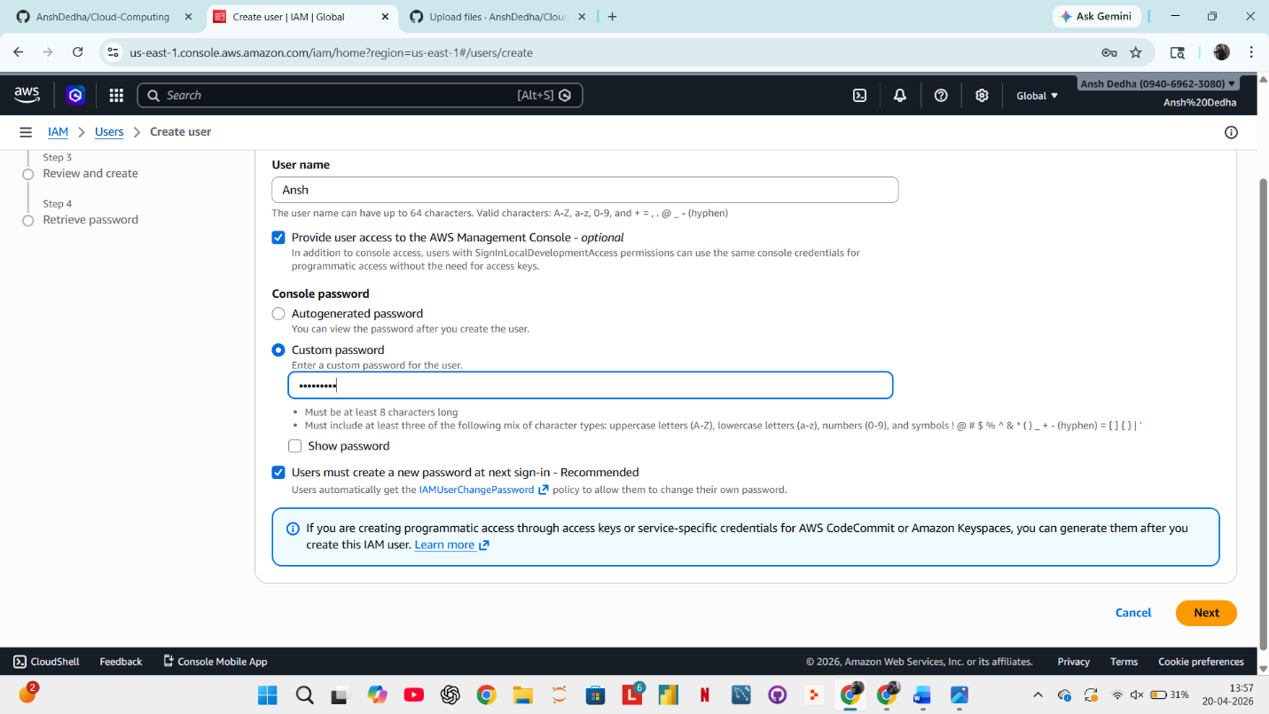
Step4 – Setting permissions for the user
- Select attach policies directly
- Now provide any policy of your choice to the user .Here I have given my user “AmazonS3FullAccess”
- 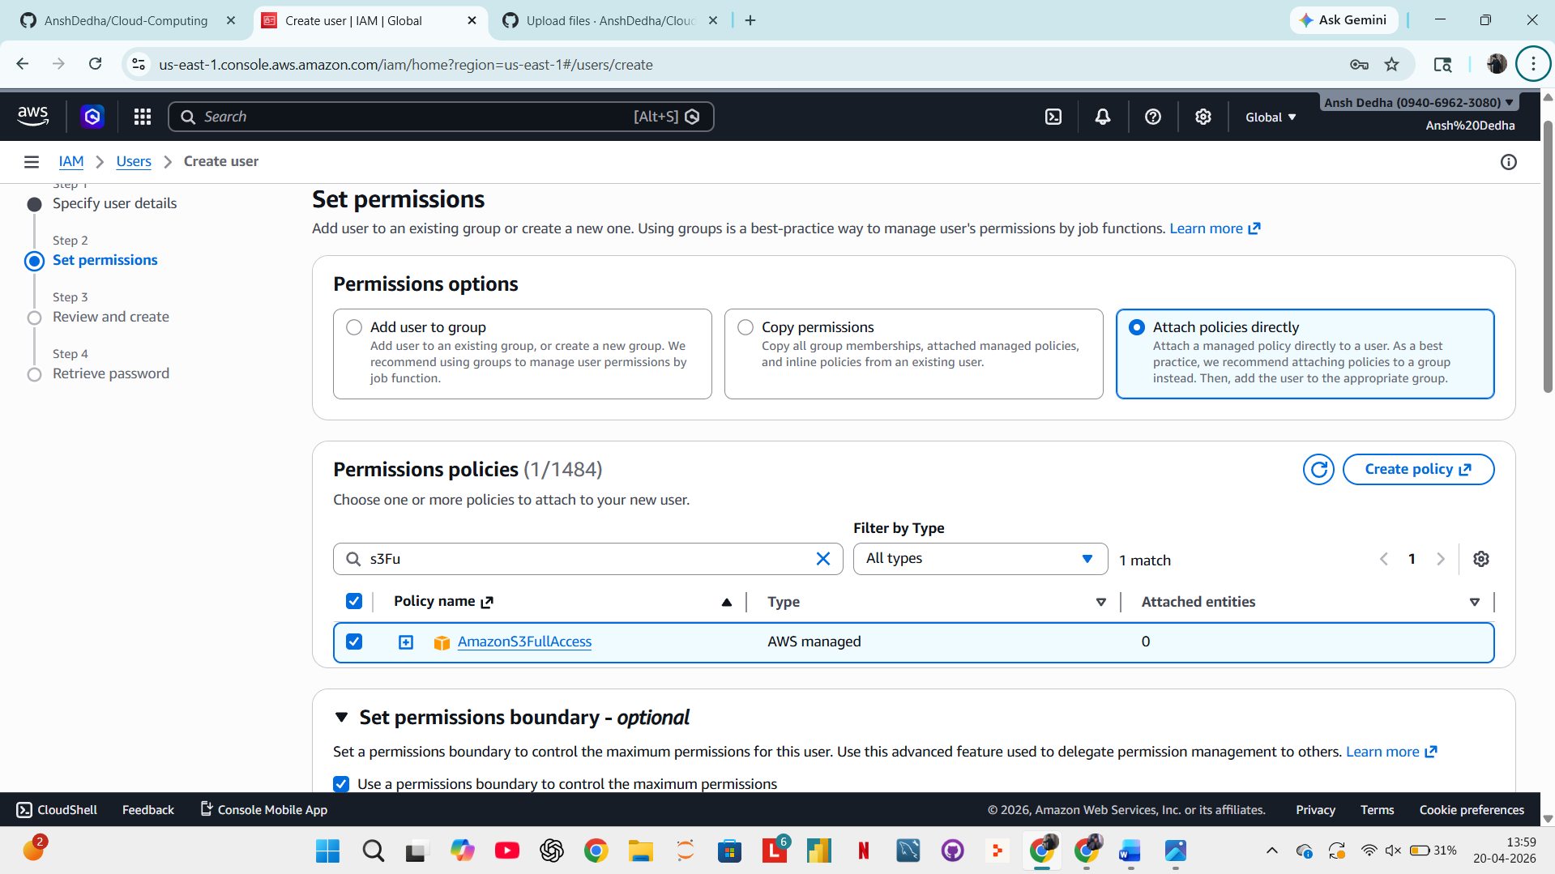
- Step-5 Review User details and Click on “Create User”
- 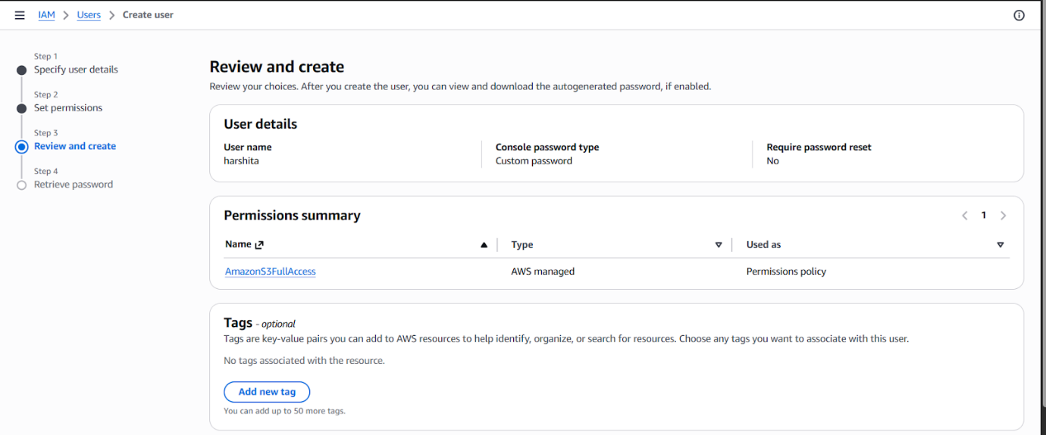

Step 6 Create Second User
Repeat the same steps:
- Go to Users → Create user
- Enter name (e.g., User2)
- Enable console access
- Assign password
- Add to same group (Developers)
- Click Create user
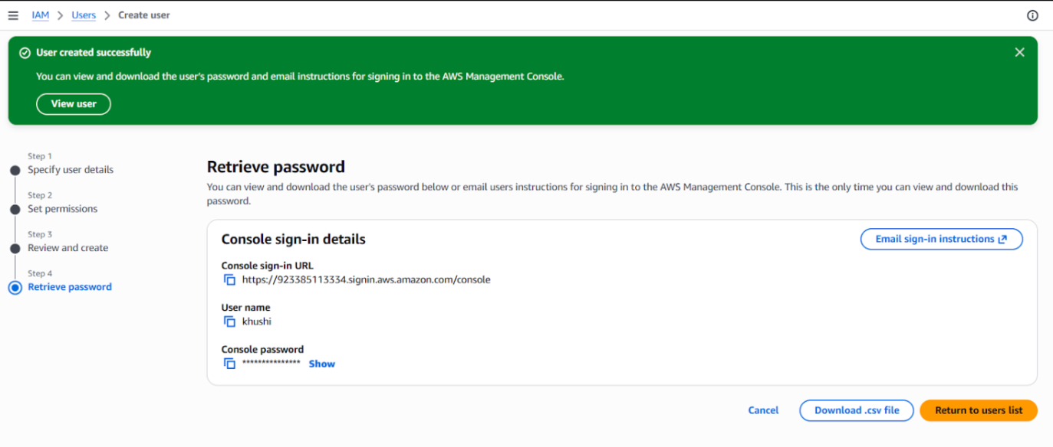

Step-7 Creating User Group
- From the IAM Dashboard .Click on User groups .
- Click on Create user group.
- Provide a name to group.
- Add users to the group.
- Add permission policies to members of the group.
- Click on Create user group.
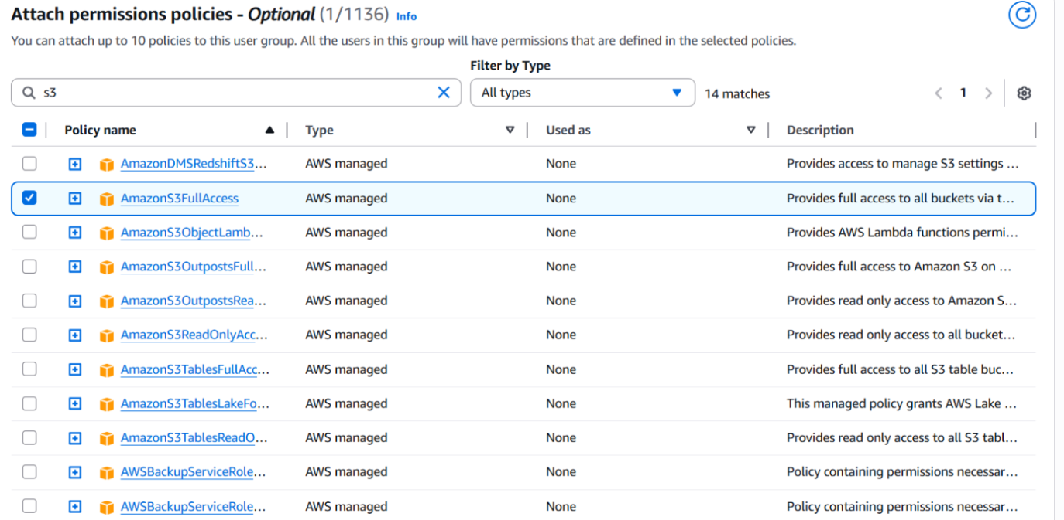

Step-8 Review group from the user group dashboard.
